DIGITAL FORENSICS INVESTIGATION REPORT USING AUTOPSY

BY: TUMWEBAZE DISSAN 23/BIT/BU/R/0005

1. INTRODUCTION
Digital forensics is the process of identifying, preserving, analyzing, and presenting digital evidence in a manner that is legally acceptable. It is widely used in cybercrime investigations, incident response, and data recovery.
This report presents a forensic investigation conducted using Autopsy, an open-source digital forensics tool. The investigation focuses on analyzing the disk image nps-2009-canon2-gen1.E01 to identify user activities, recover deleted files, and uncover any suspicious evidence.

2. OBJECTIVES
- To analyze a forensic disk image using Autopsy
- To recover deleted files
- To identify suspicious and accessed files
- To examine web activity
- To perform keyword searches
- To reconstruct events using timeline analysis

3. METHODOLOGY
The investigation followed standard digital forensic procedures:
- Acquisition – Using the provided forensic image (E01 format)
- Preservation – Ensuring no modification of original evidence
- Analysis – Using Autopsy tools and modules
- Documentation – Recording findings and observations

4. Findings By Task.
Task one – installation and set up
Digital forensics is the process of collecting, preserving, analyzing, and presenting digital evidence from electronic devices in a way that is legally acceptable.
Autopsy is an open-source digital forensics tool used to analyze disk images, recover deleted files, and investigate user activity.

Installation and Setup
- Autopsy was downloaded and installed successfully
- The application was launched
- A new case was created by entering:
- Case name
- Examiner name
- Case directory

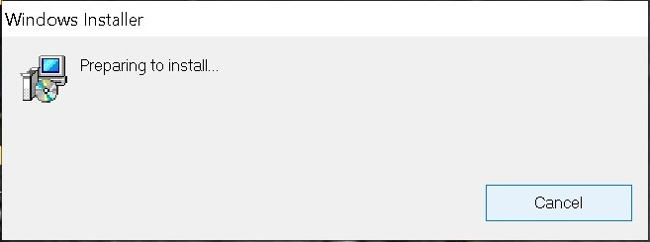
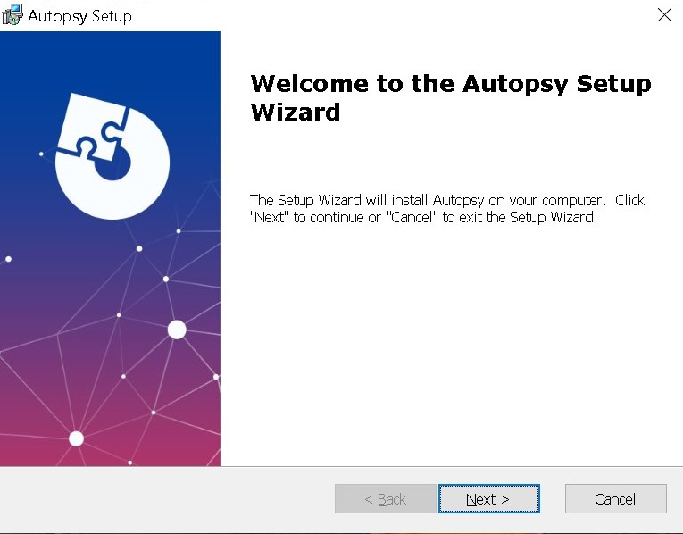

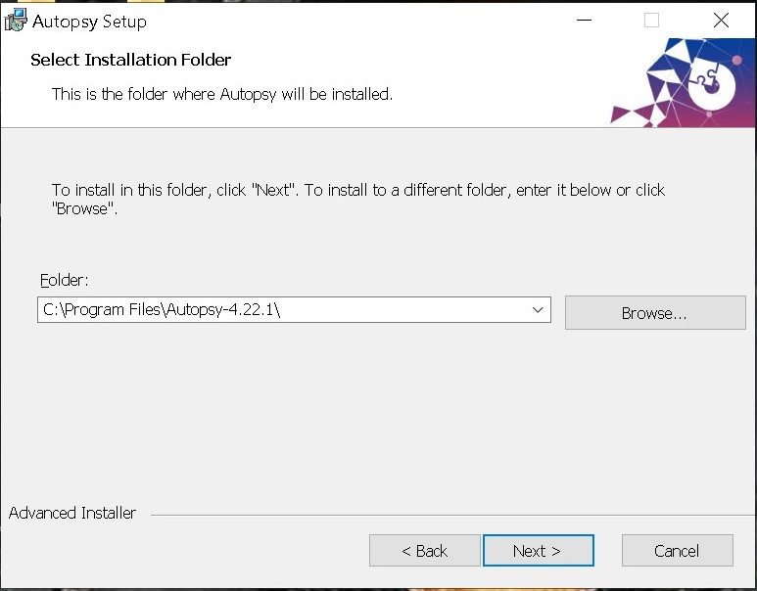
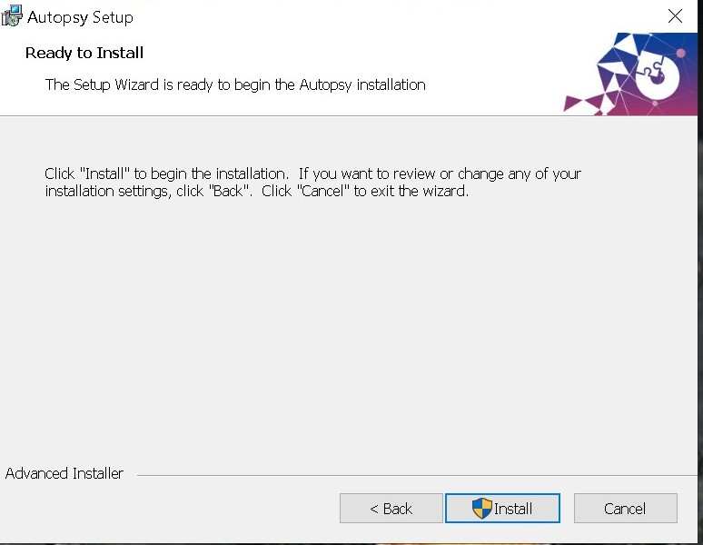
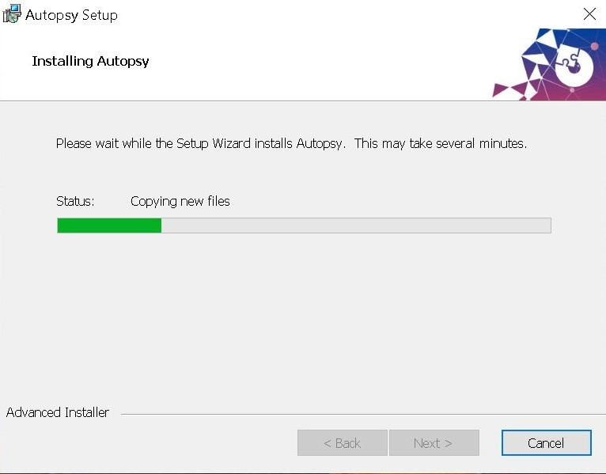
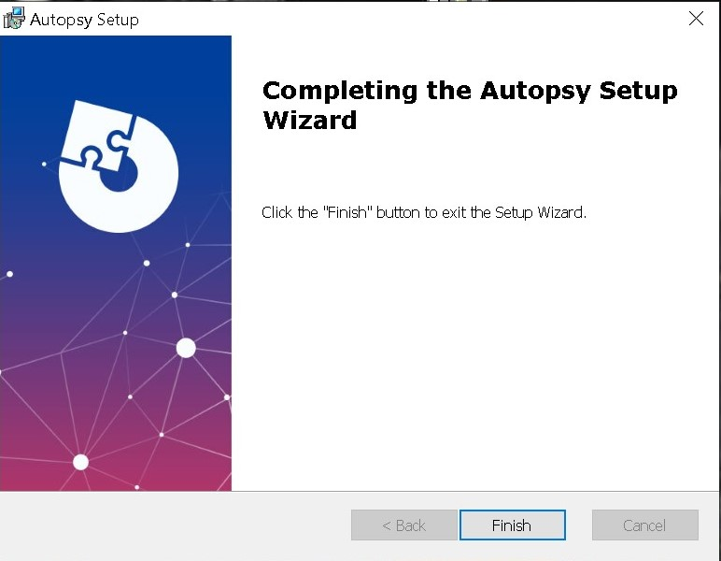
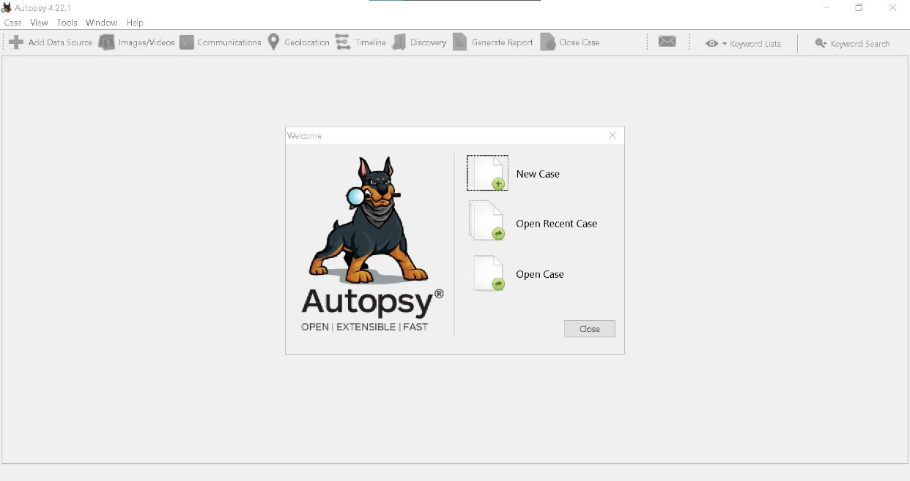

Task two – case creation and evidence loading
A forensic image is a complete, bit-by-bit copy of a storage device that includes all files (active, deleted, and hidden) without altering the original data.

Steps Performed
- Created a new case in Autopsy
- Selected “Add Data Source”
- Loaded the disk image: nps-2009-canon2-gen1.E01
- Enabled ingest modules
- Started the analysis

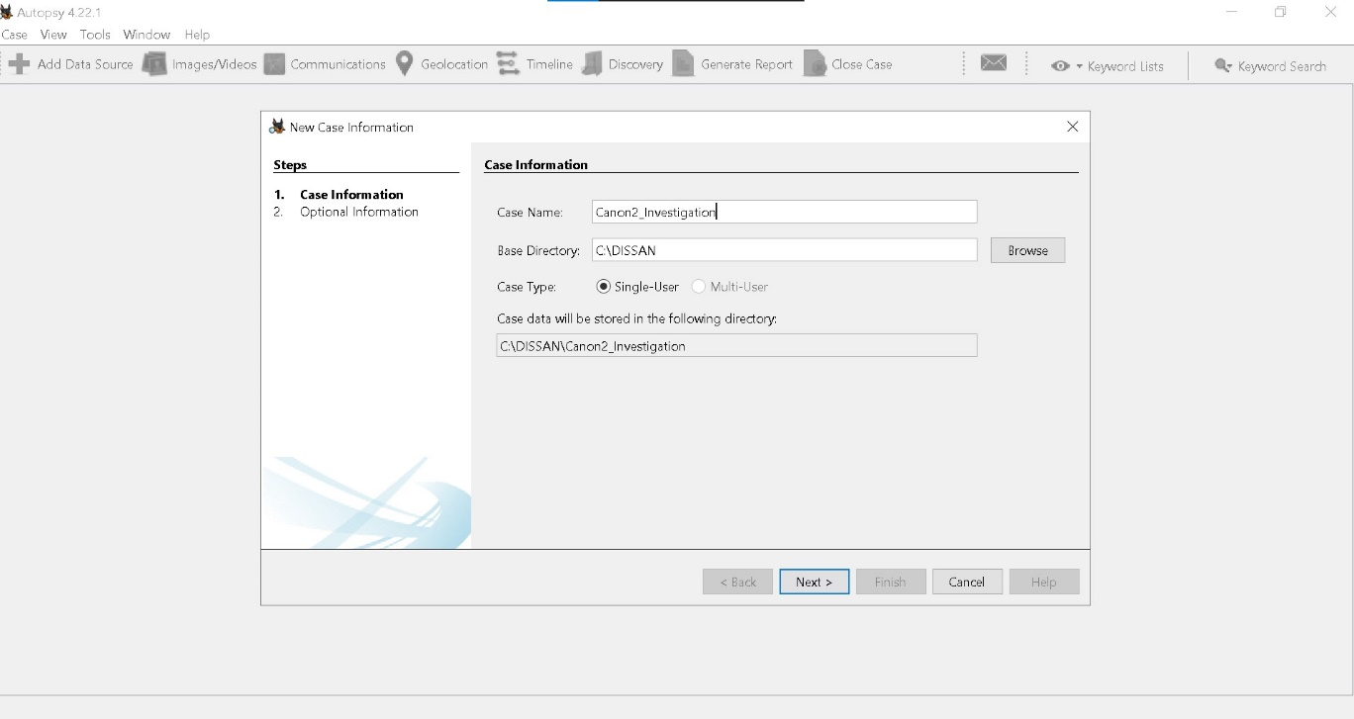
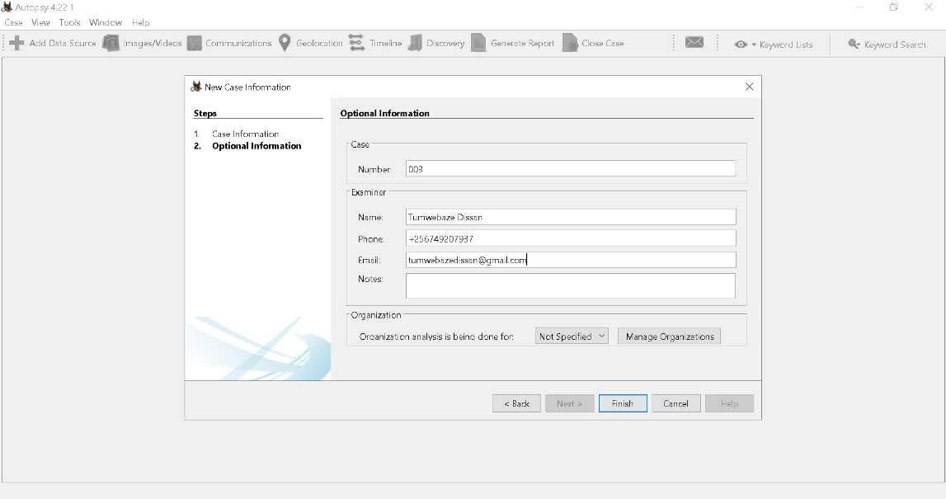
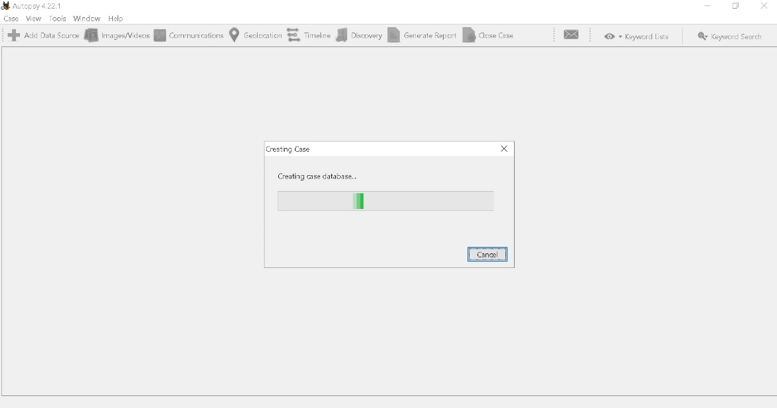
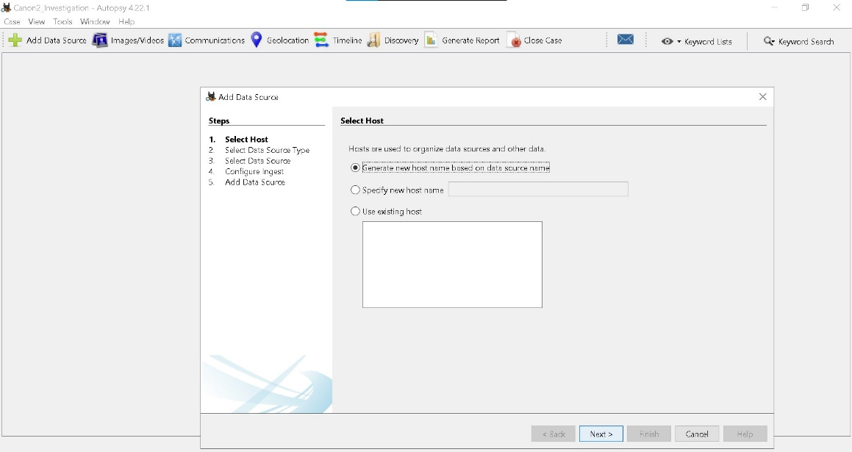
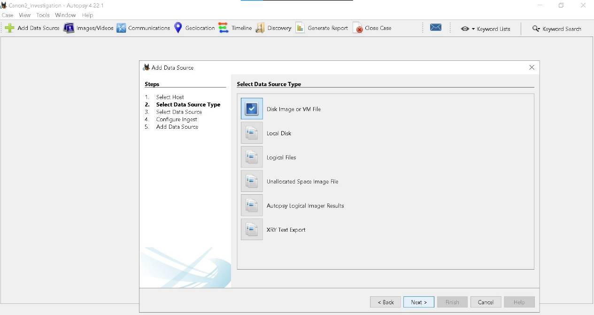
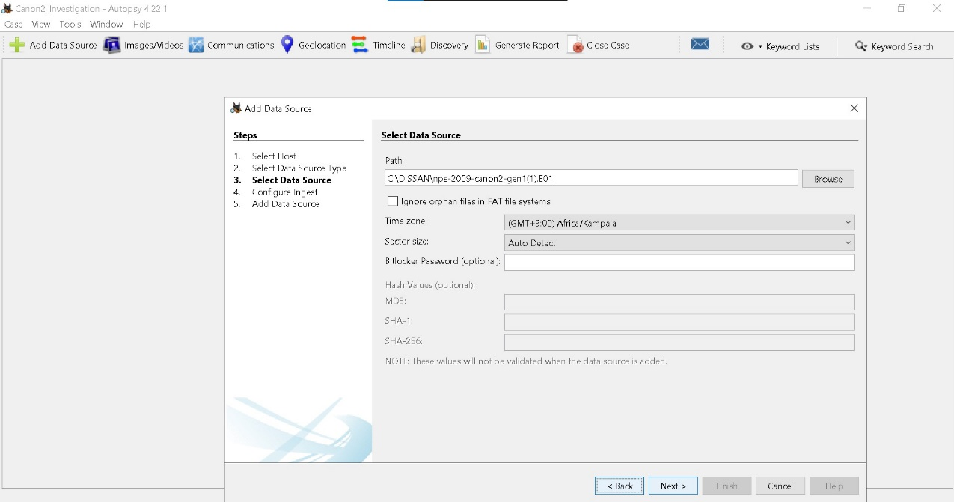
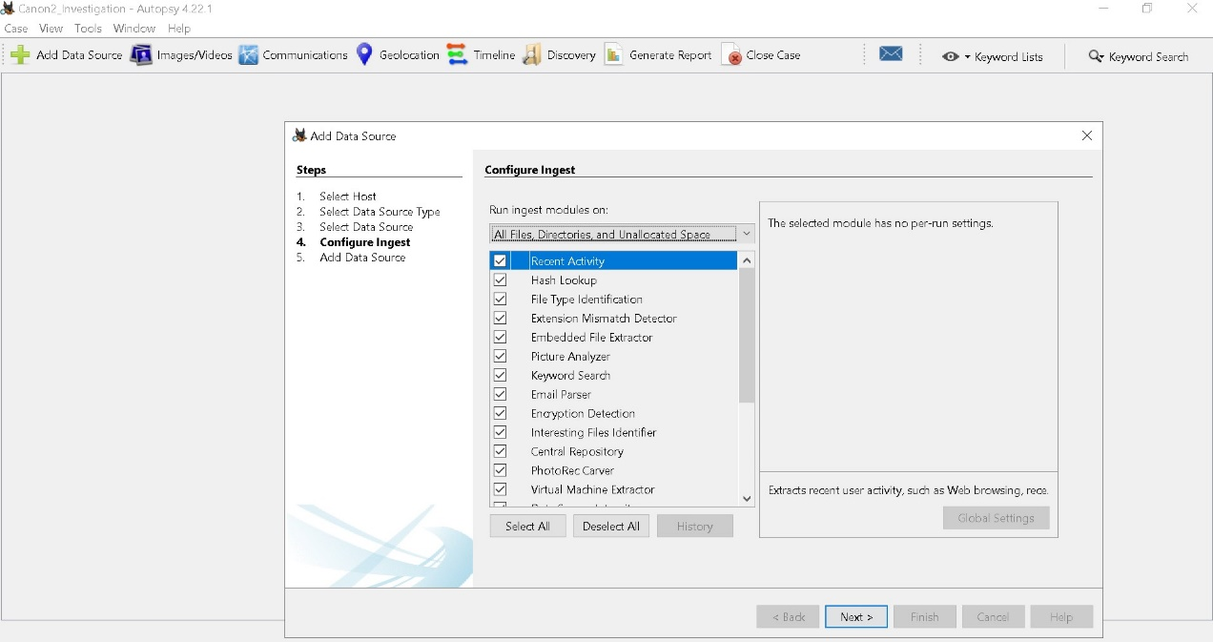
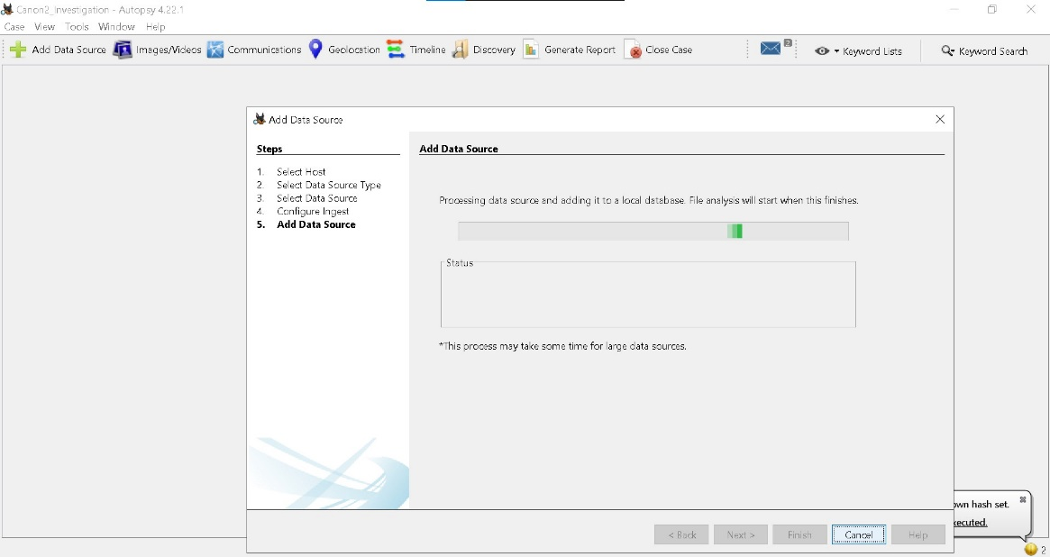
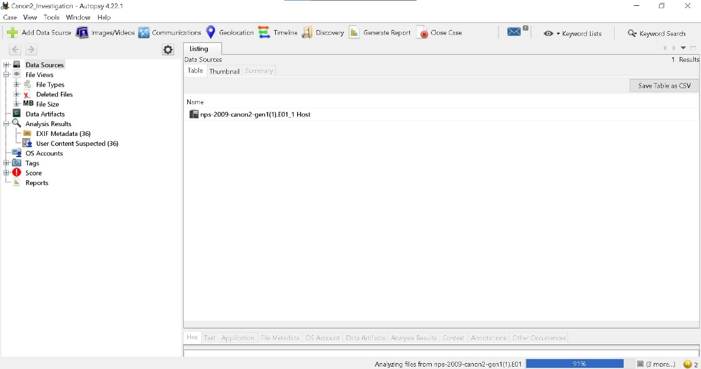

Task Three – File System Analysis
The file system was analysed to identify important and suspicious files.

Findings
- Various image files (typical of a Canon camera dataset)
- File metadata such as timestamps (created, modified, accessed)
- Recently accessed files identified through metadata

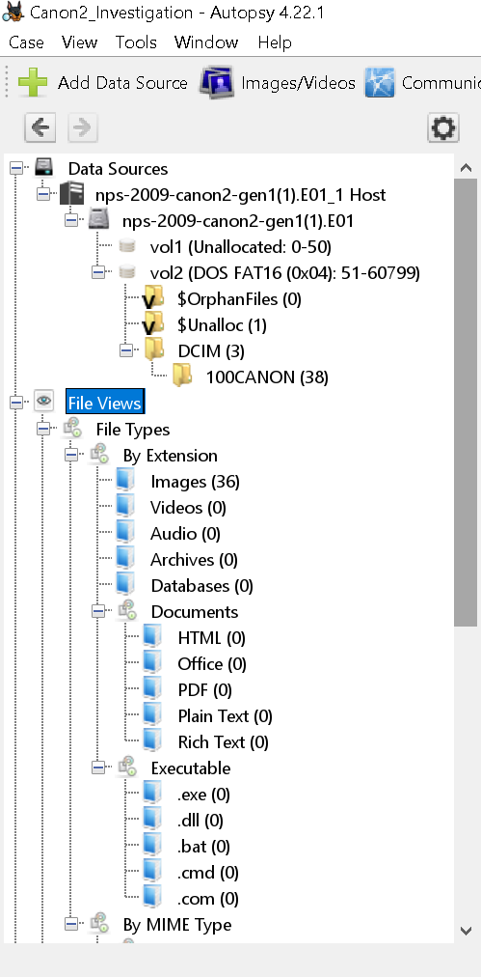

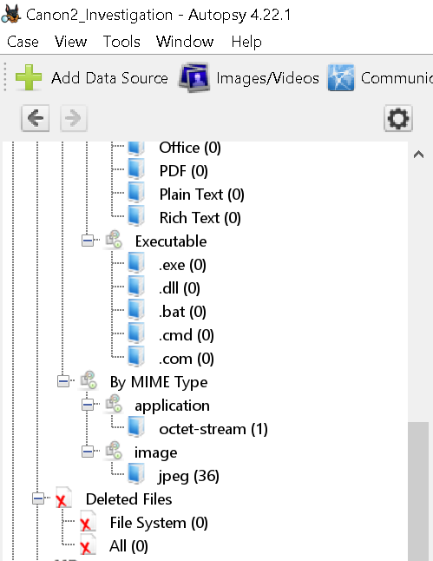

Suspicious Files
- Files with unusual names or locations
- Files accessed at irregular times
- Hidden or system files

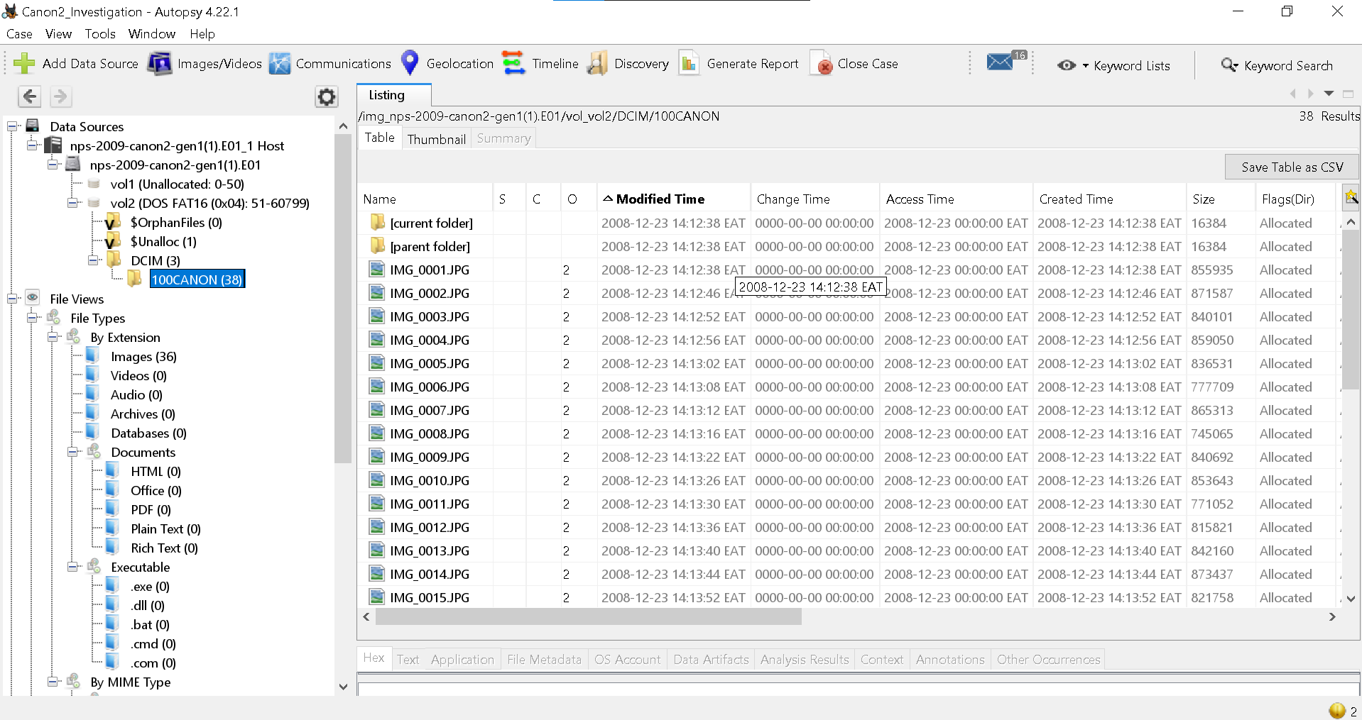

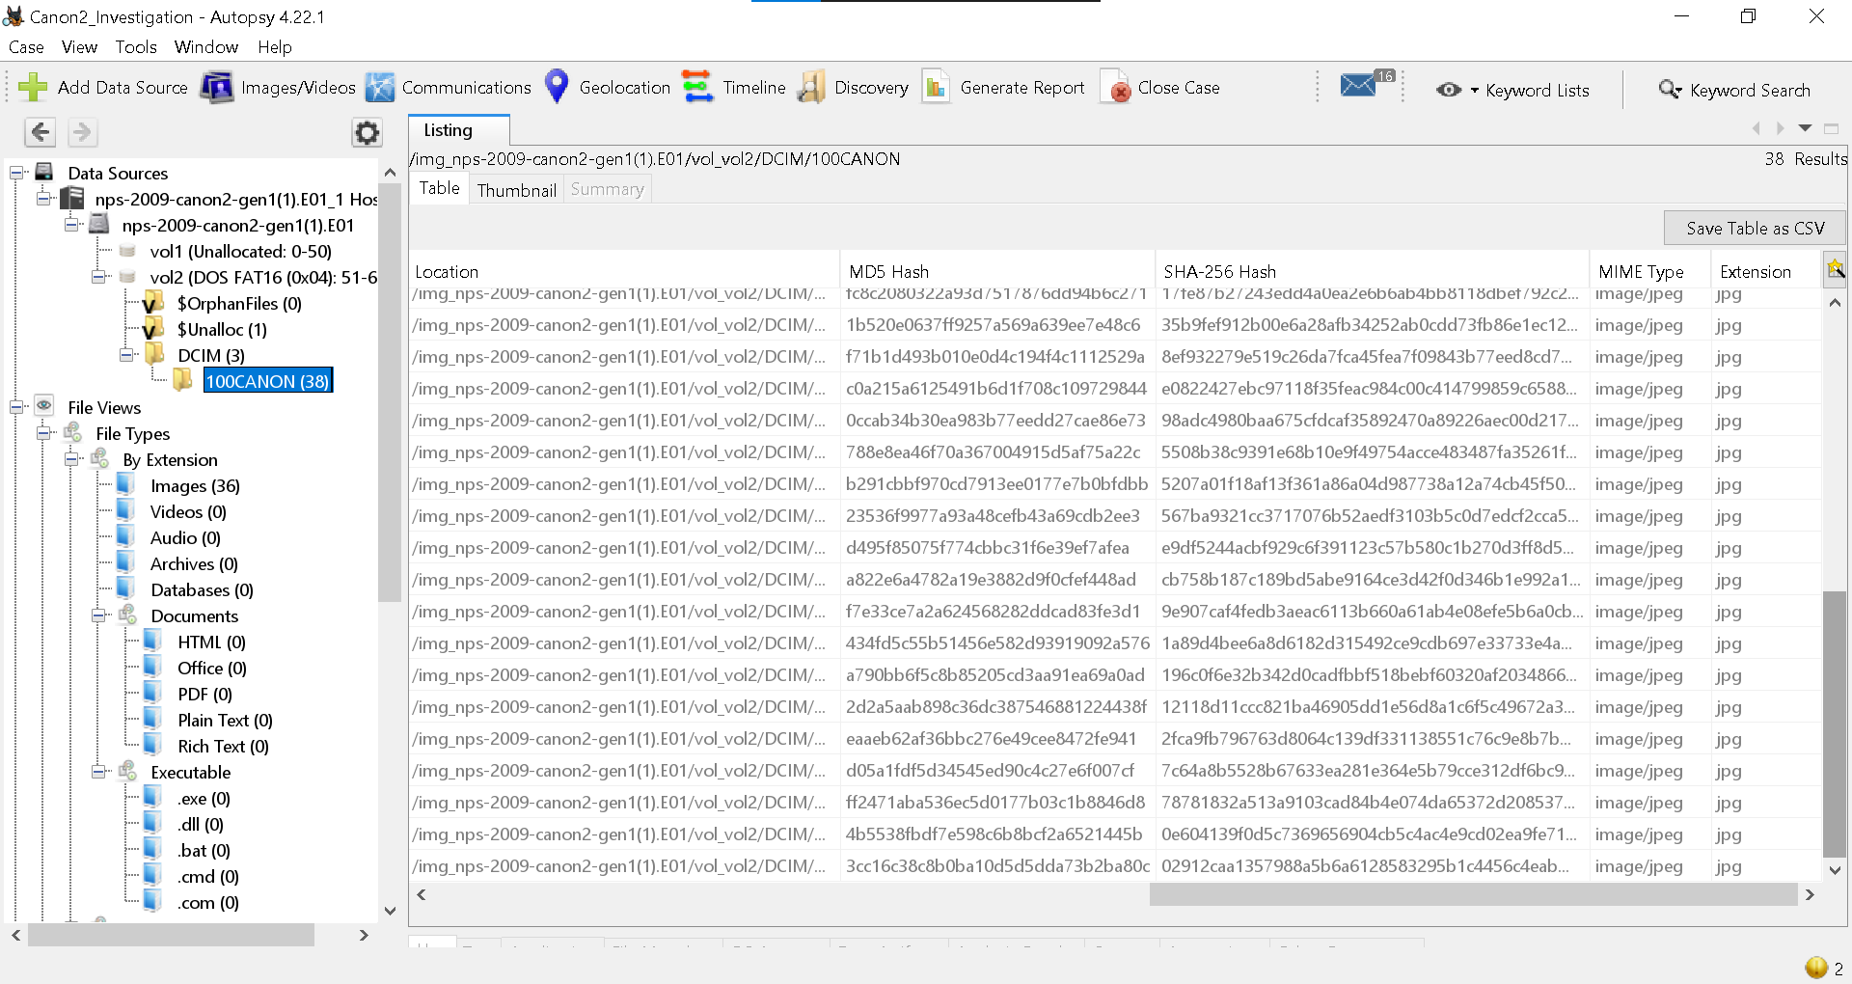

Accessed Files
- Recently opened image files
- Files with recent access timestamps indicating user activity

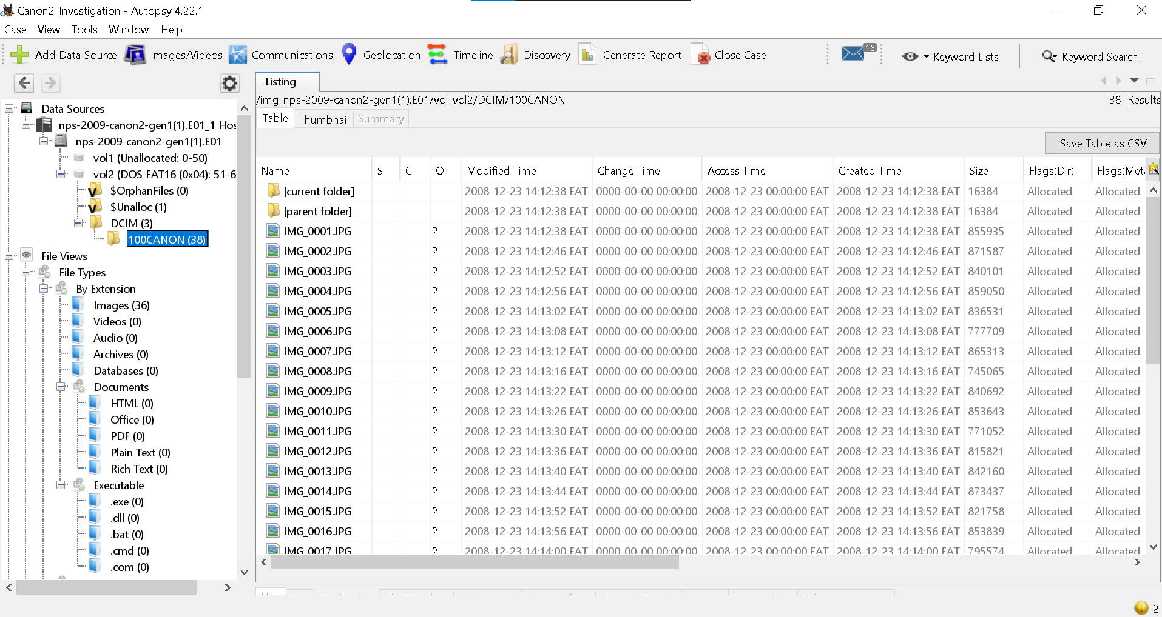

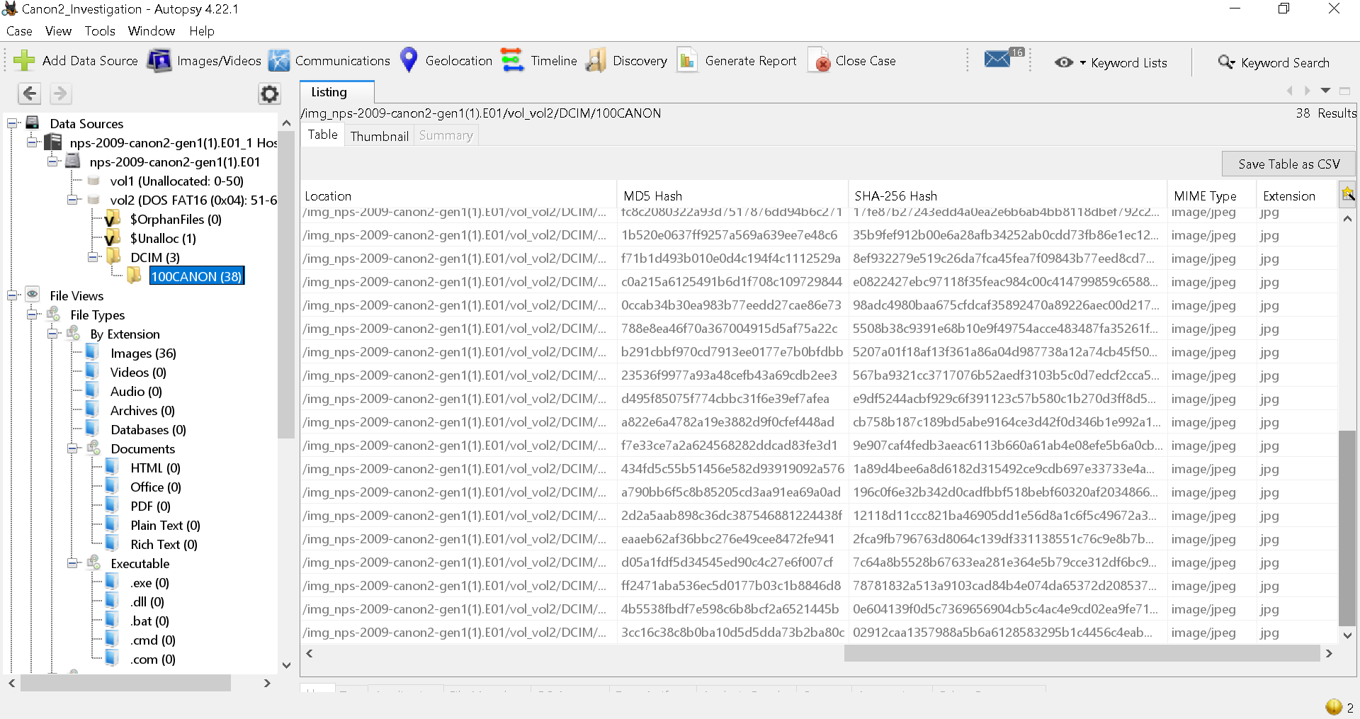

Task four – Recovery of Deleted Files
$Orphan files(0) – zero entries found
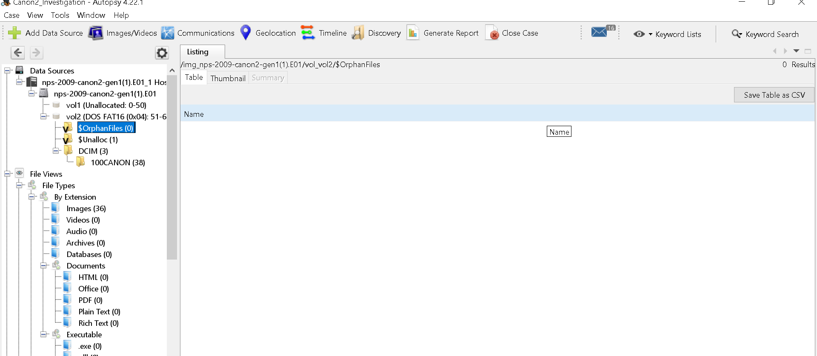

$Unalloc (1) – one entry found
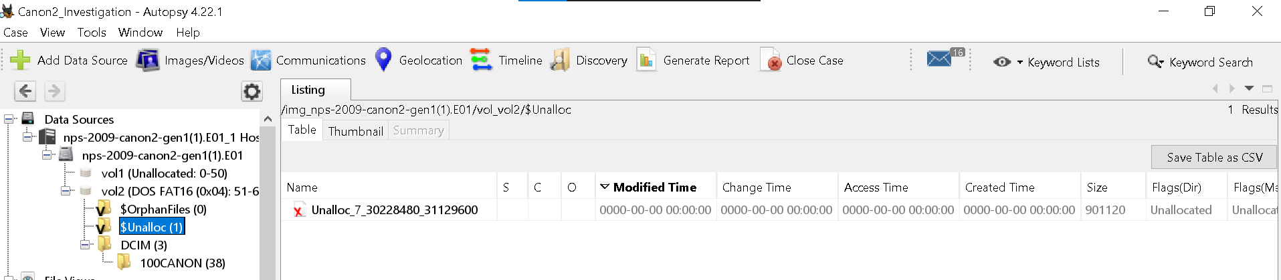

Recovered files
At least one deleted file was recovered from unallocated space.

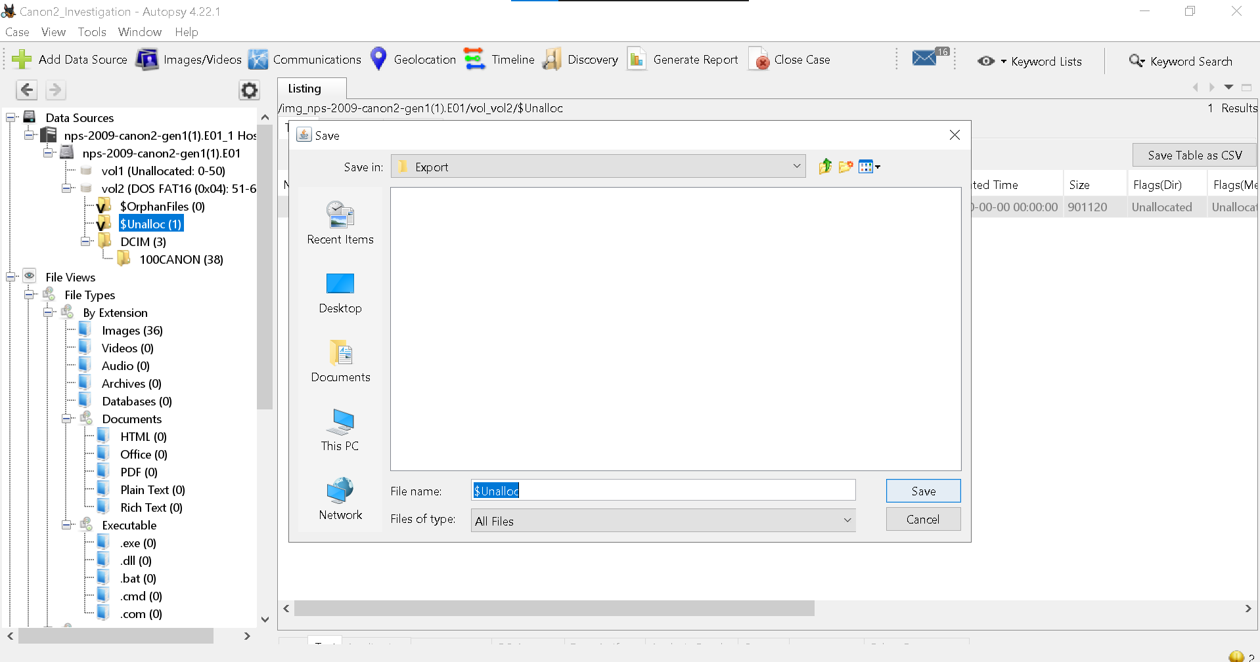

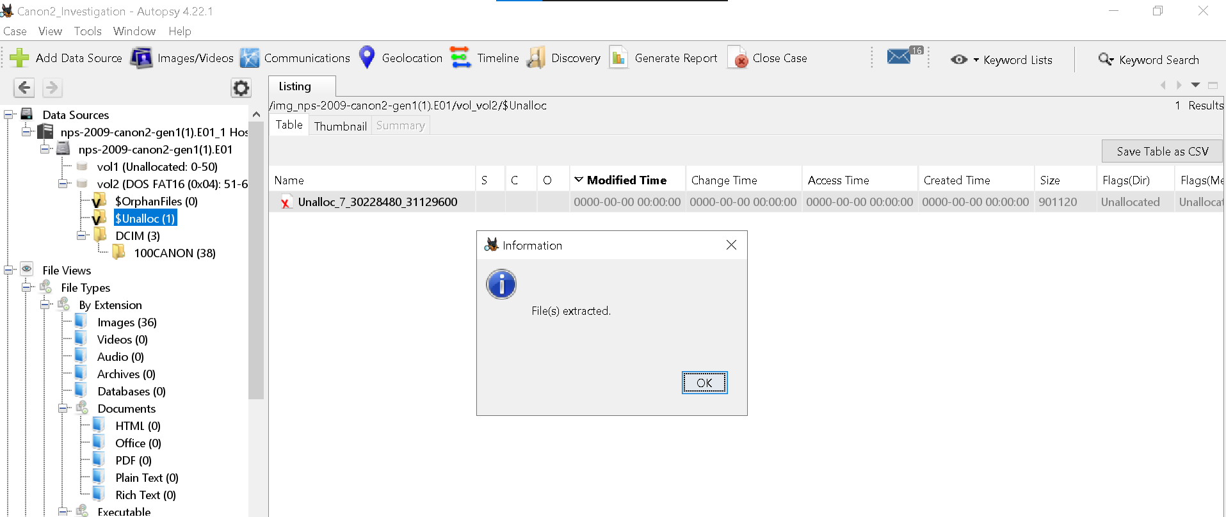

Relevance
- Demonstrates that deleted data is not permanently erased
- Provides potential evidence of user activity

Task five – web Activity Analysis
Web artifacts such as browser history, cookies, and downloads were examined.

Findings
- Limited or no browser data (expected for camera-based dataset)
- No significant web activity detected
Explanation
The evidence is a digital camera memory card, not a computer system. Therefore, absence of web activity is expected and does not indicate an issue

Task six – keyword search and Analysis
Keyword Password
Result: No results found
Indicates absence of sensitive textual data in the image
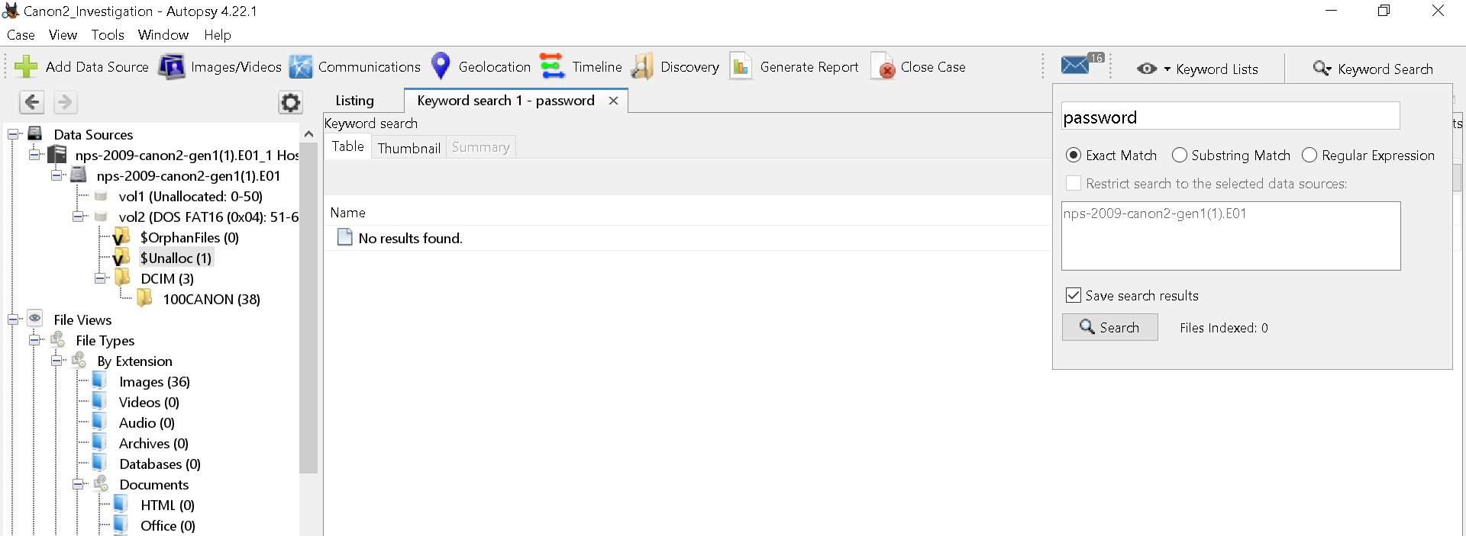

Keyword Confidential
Result: No results found
Indicates absence of sensitive textual data in the image

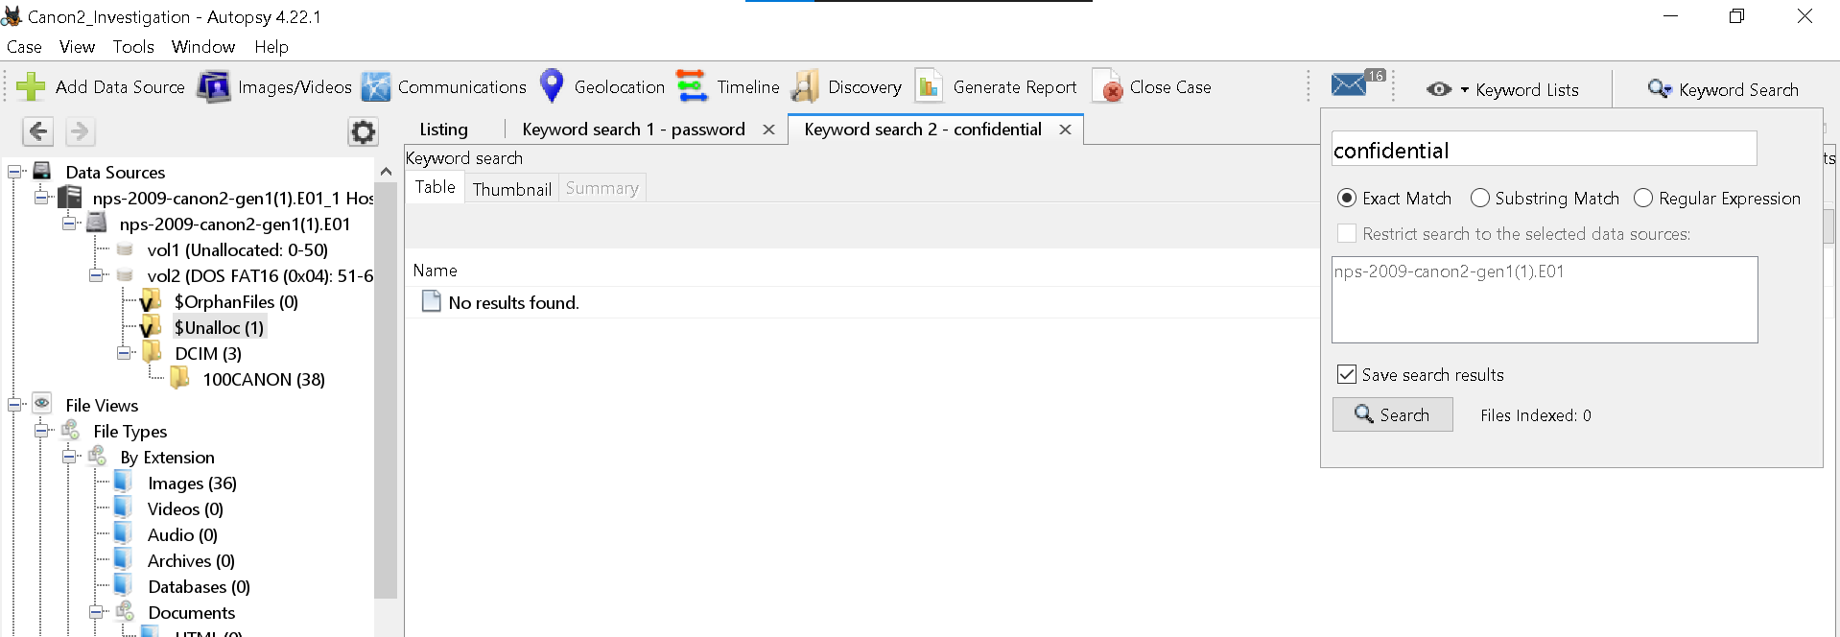

Task seven – Timeline Analysis
Autopsy timeline feature was used to reconstruct events.
Counts view
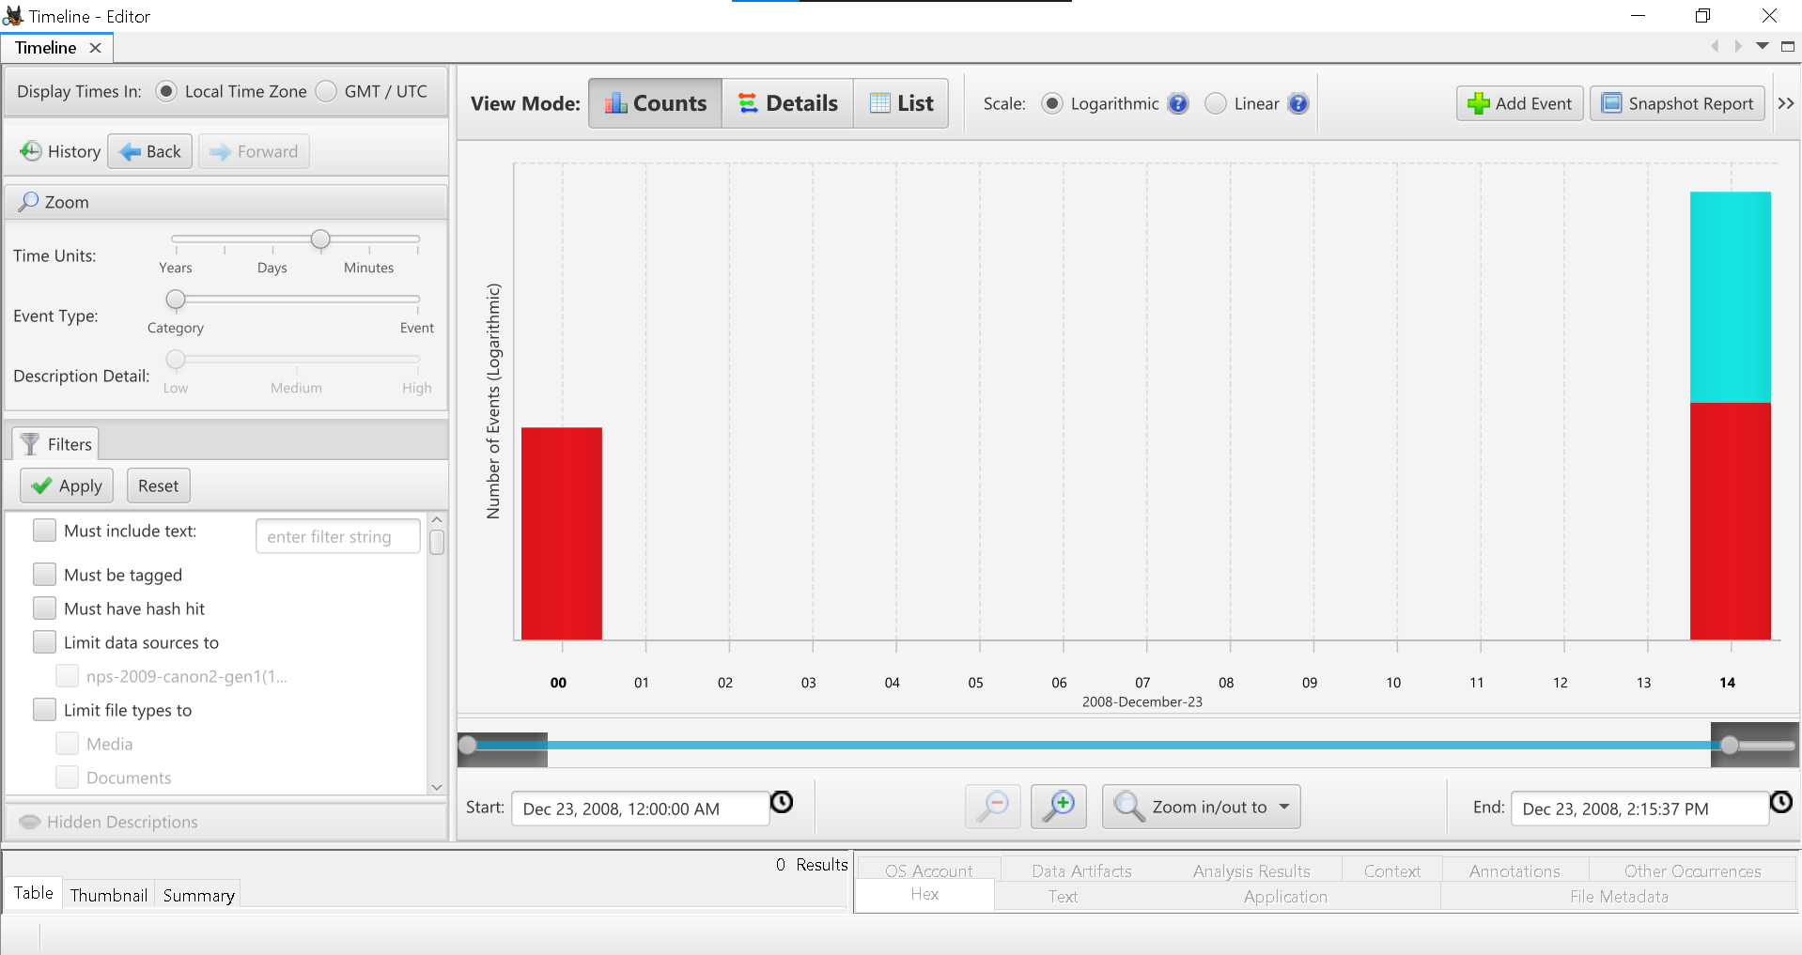

Details view
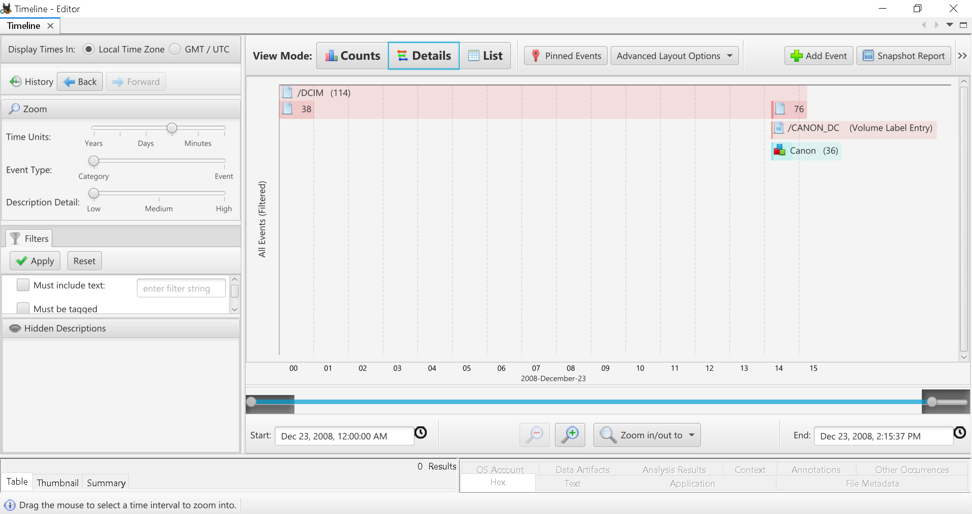

List view
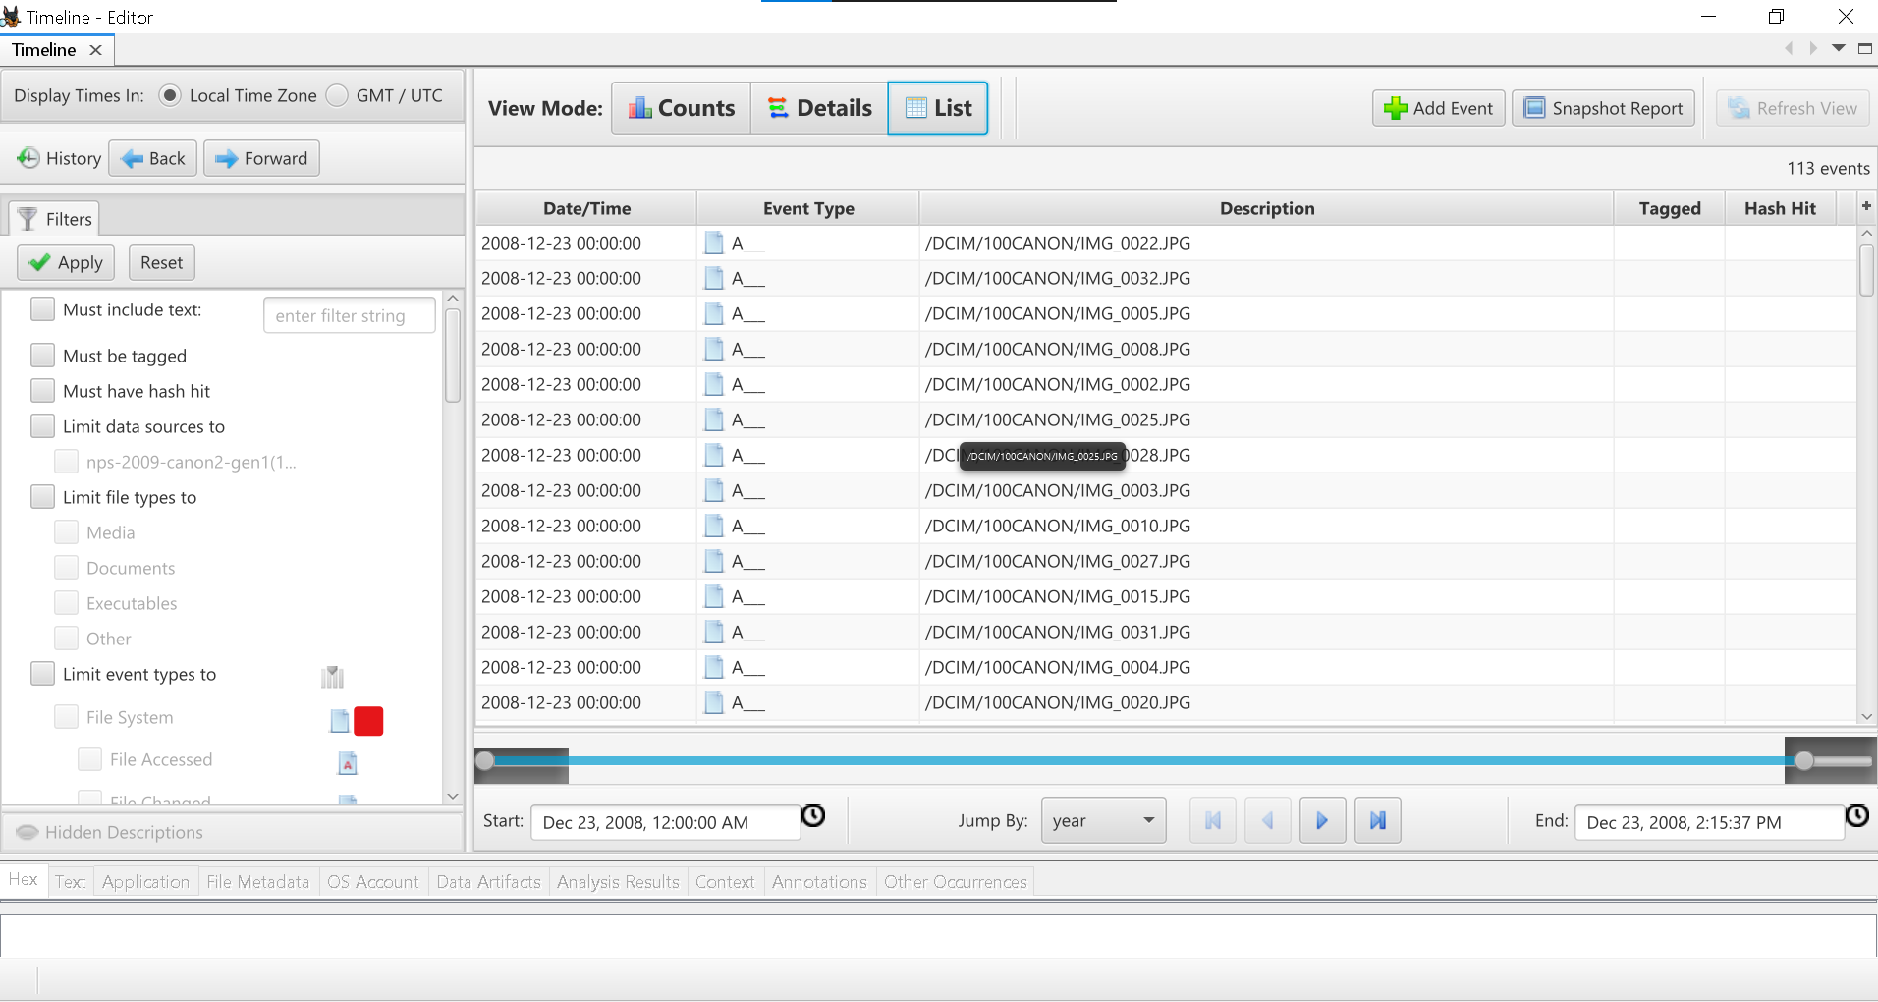

Reconstructed Events
- File creation timeline
- File access patterns
- Sequence of user actions
This helped establish a chronological order of activities.

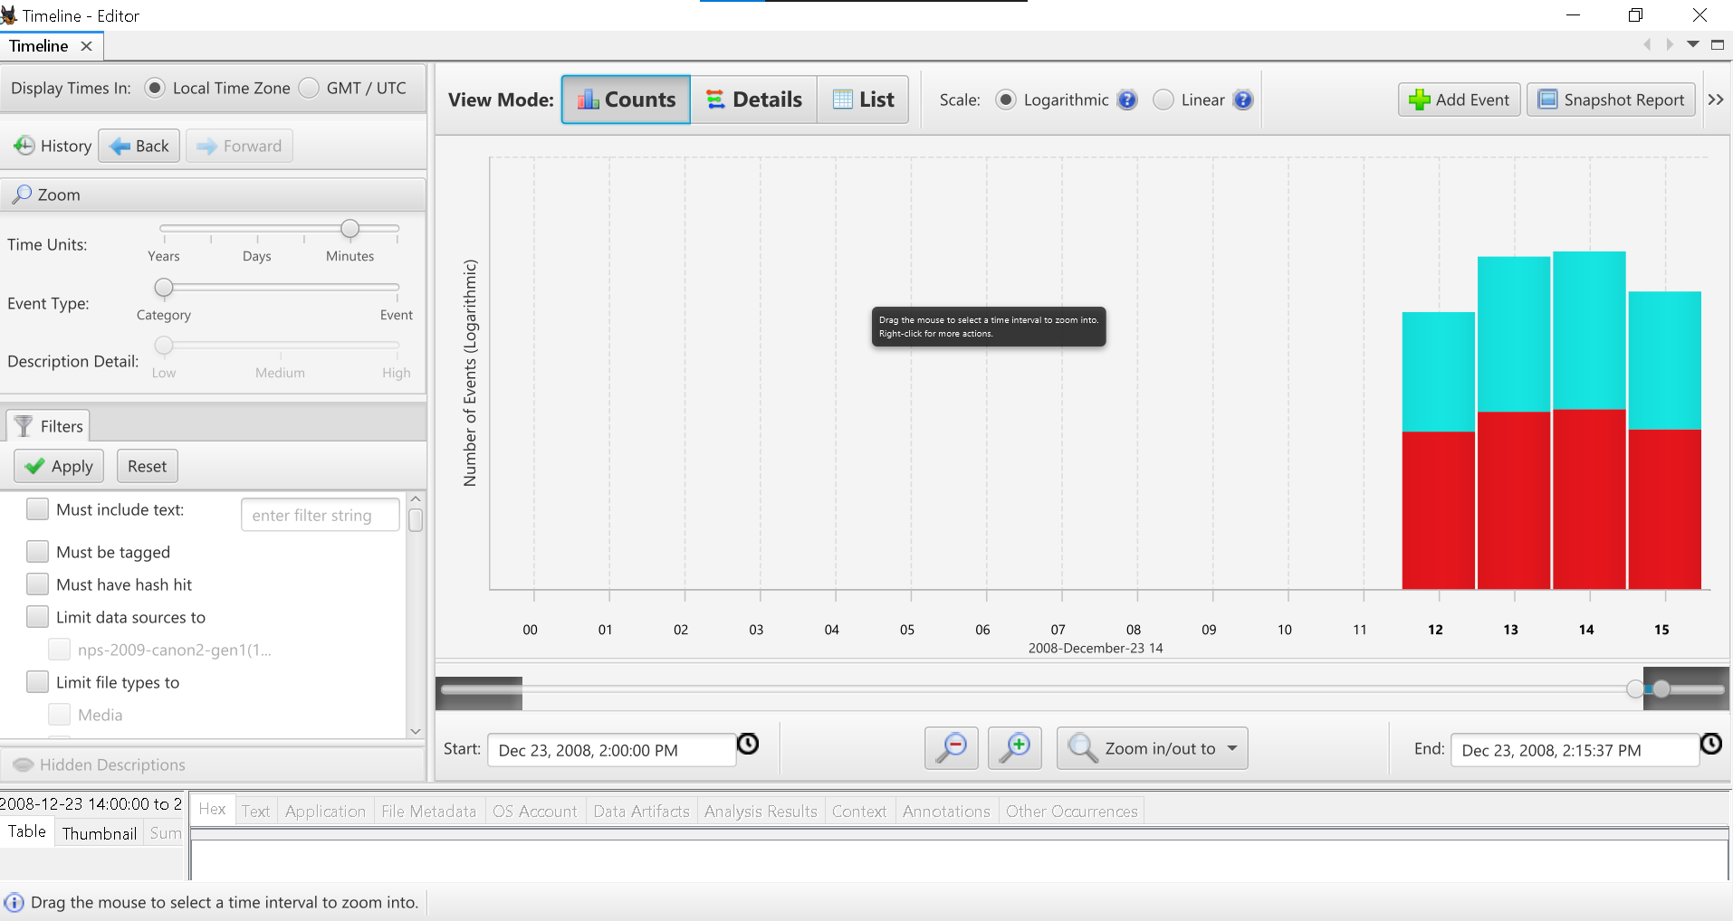

4.FINDINGS SUMMARY
- The disk image contains 38 active image files
- 1 deleted file was recovered
- No evidence of browsing activity
- No sensitive keyword matches found

5. CONCLUSION
The investigation successfully demonstrated the use of Autopsy in digital forensic analysis. Key forensic processes such as file system analysis, deleted file recovery, keyword searching, and timeline reconstruction were performed effectively.
The disk image did not show strong evidence of malicious activity but provided valuable insight into how digital evidence can be analysed and interpreted.

